Address book Labels and Contacts

There are three main folders in the address book, which have sub (department) folders with Labels. These can be used to group contacts.
Contacts can be added to department folders and department labels individually.

Main folders
User
Department
Organization

(Export as shown below, is a department label)
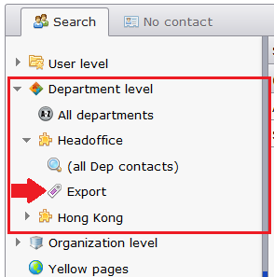

To create a new label, go to a department folder and click on the Create label button that appears above.
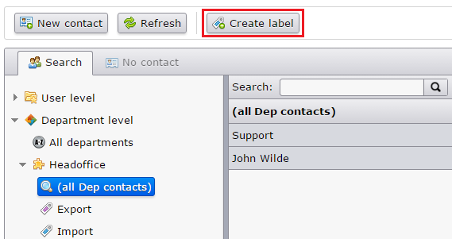

In the pop-up screen, enter the name in the text box field, and you can highlight the label with a color. When finished press Ok.
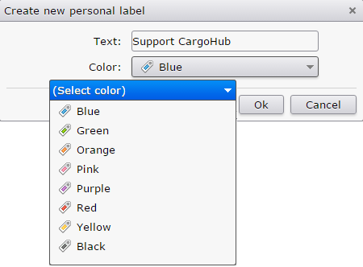

To rename or delete a label, select the label you want to change and then the button above.
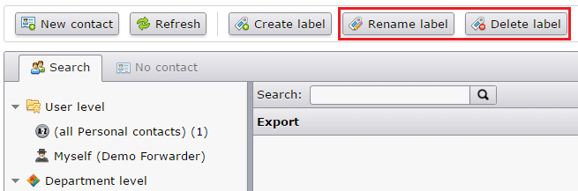
Rename: Edit/overwrite the shown name. You can also change the label color here.
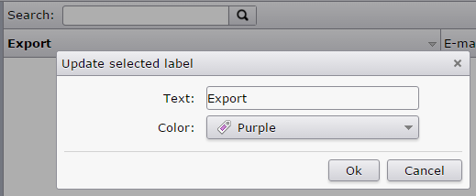
If you delete a label, the contacts will be saved in the department folder.

To move a contact, select one or more contacts in your overview and go to the Set label
button above, to reassign it to another (group) label.

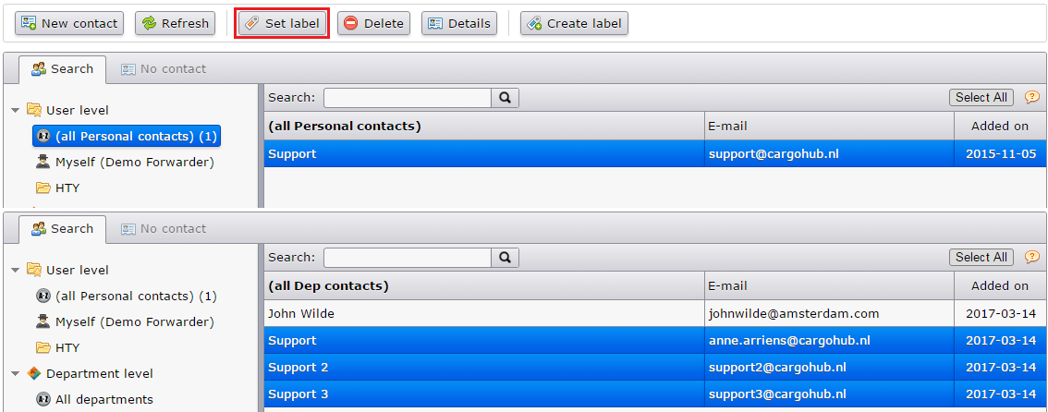

In the pop-up, choose the new department label and select Ok to save.
Contacts can be assigned to any label, only within the same department folder.

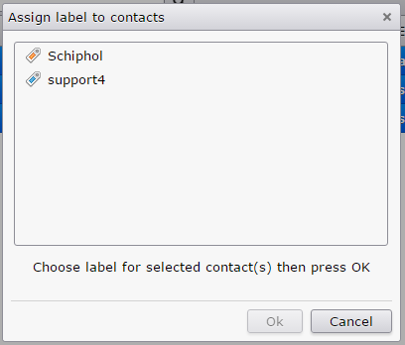

A confirmation message will appear after saving.
If the message ‘set for 0 contacts’ appears, no contacts have been moved or the contact may have been assigned its own label.



